SF.SmokeTest_Manager_TC_SF_ManagerLogin_Instance1_12-Apr-2017_10-32-45_AM_Invoke_Application.png



SF.SmokeTest_Manager_TC_SF_ManagerLogin_Instance1_12-Apr-2017_10-32-54_AM_Login.png

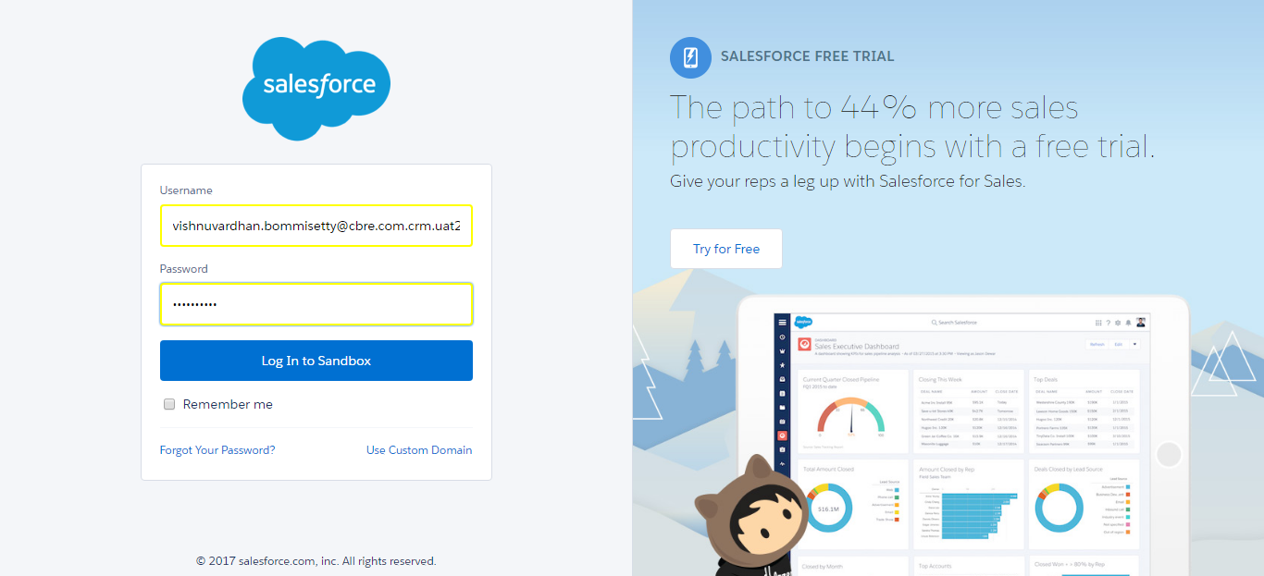

SF.SmokeTest_Manager_TC_SF_ManagerLogin_Instance1_12-Apr-2017_10-32-56_AM_Error.png

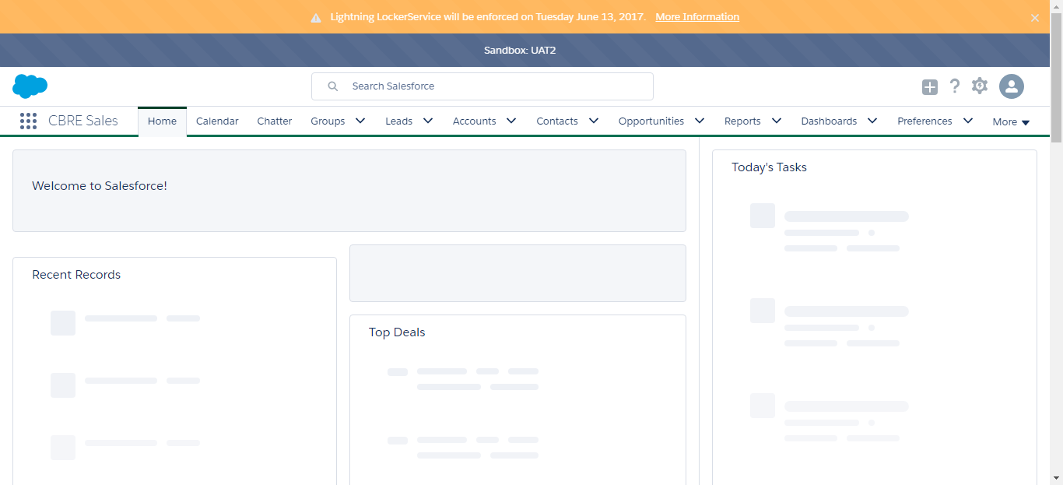

SF.SmokeTest_Manager_TC_SF_ManagerLogin_Instance1_12-Apr-2017_10-33-09_AM_Invoke_Application.png



SF.SmokeTest_Manager_TC_SF_ManagerLogin_Instance1_12-Apr-2017_10-33-17_AM_Login.png

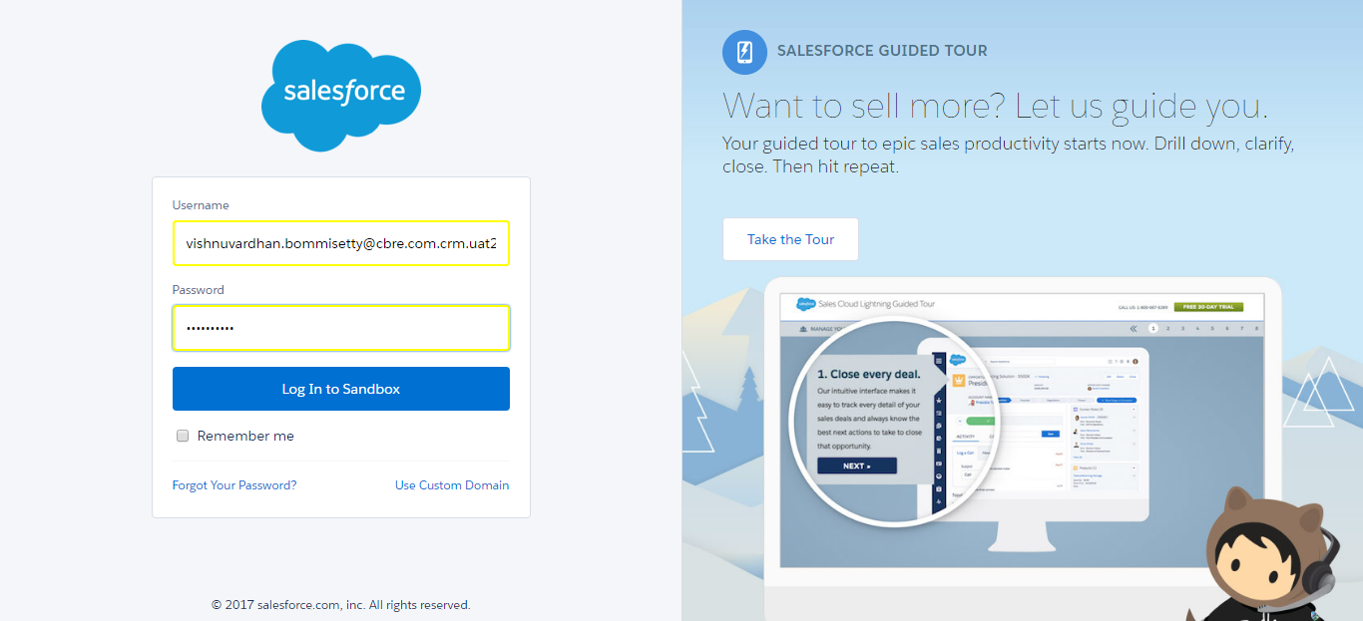

SF.SmokeTest_Manager_TC_SF_ManagerLogin_Instance1_12-Apr-2017_10-33-19_AM_Error.png

